**G. H. RAISONI COLLEGE OF ENGINEERING, NAGPUR**

**(An Autonomous Institute affiliated to Rashtrasant Tukdoji Maharaj, Nagpur University, Nagpur)**

**Department of Computer Science & Engineering**

**Date: 02/04/2021**

**Practical Subject: Java Programming**

**Session: 2020-21**

**Group Details:**

|  |  |
| --- | --- |
| **Name** | Shrushti Rajanhire, Shubham Ashish |
| **Roll** | 10, 33 |
| **Semester** | IV |
| **Section** | C |
| **Branch** | CSE |

**Project** **Details: Voter Management System Practical Number-10**

**Project Aim**: Submit complete project having 4-5 module like sign in, login, Insertion, deletion, search, update and display data.

**Project Complete code with Snapshot:**

**Welcome page code:**

private void LOGINActionPerformed(java.awt.event.ActionEvent evt) {

setVisible(false);

new Loginform().setVisible(true);

}

private void createaccountActionPerformed(java.awt.event.ActionEvent evt) {

setVisible(false);

new Login_form().setVisible(true);

}

**Snapshot**

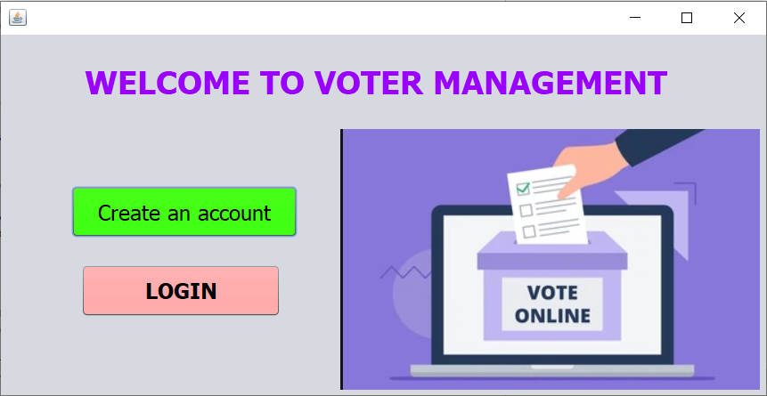

**Login Page code:**

private void loginActionPerformed(java.awt.event.ActionEvent evt) {

String user = usernametextfield.getText();

String pass1 = passwordtextfield.getText();

if(user.trim().equals("admin") && (pass1.trim().equals("12345")))

{

JOptionPane.showMessageDialog(null,"Valid User");

setVisible(false);

new Menu();

}

else

{

JOptionPane.showMessageDialog(null,"Invalid User");

}

}

private void exitActionPerformed(java.awt.event.ActionEvent evt) {

// TODO add your handling code here:

System.exit(0);

}

**Snapshot**

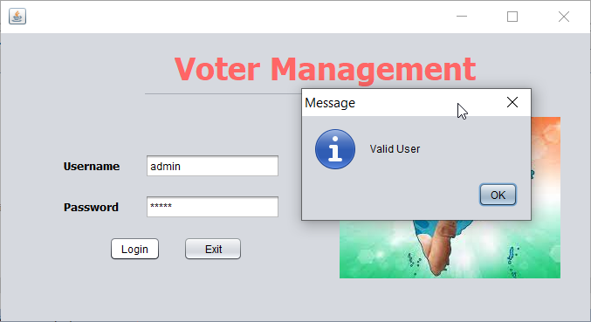

**Create Account Page Code:**

Connection con;

PreparedStatement pst;

public Login_form() {

try {

initComponents();

setVisible(true);

Class.forName("org.apache.derby.jdbc.ClientDriver");

con=DriverManager.getConnection("jdbc:derby://localhost:1527/Project","admins","admins");

JOptionPane.showMessageDialog(null,"DataBase Connected");

pst=con.prepareStatement("insert into FIRST_NAME values(?,?,?,?,?)");

}

catch (ClassNotFoundException ex) {

Logger.getLogger(Login_form.class.getName()).log(Level.SEVERE, null, ex);}

catch (SQLException ex) {

Logger.getLogger(Login_form.class.getName()).log(Level.SEVERE, null, ex);}

}

private void signupActionPerformed(java.awt.event.ActionEvent evt) {

String fname1 = name.getText();

String lname1 = lname.getText();

String email1 = email.getText();

String pass1 = pass.getText();

String contact1=contact.getText();

int contact_number=Integer.parseInt(contact1);

String conpass = confirmpass.getText();

try{

if((conpass.trim().equals(pass1)))

{

pst.setString(1,fname1);

pst.setString(2,lname1);

pst.setString(3,email1);

pst.setInt(4,contact_number);

pst.setString(5,pass1);

int res=pst.executeUpdate();

if(res>=1)

{

JOptionPane.showMessageDialog(null,"Account Created Successfully");

setVisible(false);

new Menu().setVisible(true);

}

else

{

JOptionPane.showMessageDialog(null,"Invalid Password");

}

}

}

catch(Exception e){

JOptionPane.showMessageDialog(null,e.getMessage());

}

}

**Snapshot**

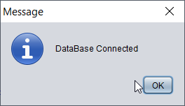

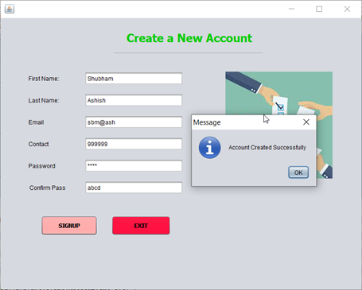

**Menu Page:**

private void exitActionPerformed(java.awt.event.ActionEvent evt) {

System.exit(0);

}

private void createaccountActionPerformed(java.awt.event.ActionEvent evt) {

setVisible(false);

new Login_form().setVisible(true);

}

private void loginActionPerformed(java.awt.event.ActionEvent evt) {

setVisible(false);

new Loginform().setVisible(true);

}

private void adddetailActionPerformed(java.awt.event.ActionEvent evt) {

// TODO add your handling code here:

setVisible(false);

new insert().setVisible(true);

}

private void searchdetailActionPerformed(java.awt.event.ActionEvent evt) {

// TODO add your handling code here:

setVisible(false);

new search().setVisible(true);

}

private void editdetailActionPerformed(java.awt.event.ActionEvent evt) {

// TODO add your handling code here:

setVisible(false);

new edit().setVisible(true);

}

**Snapshot**

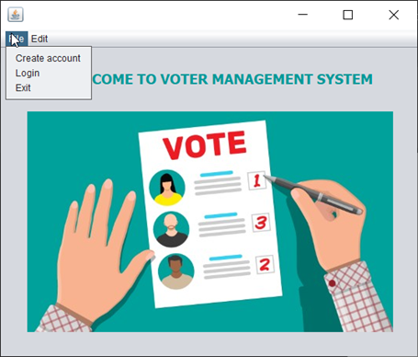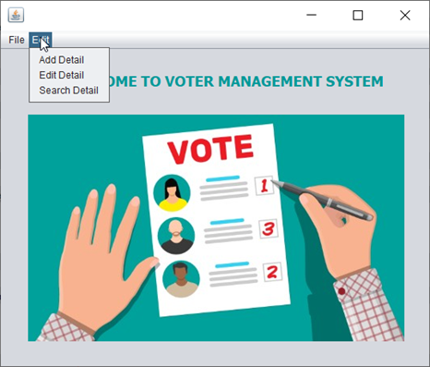

**Insert Page:**

import javax.swing.JOptionPane;

import java.sql.*;

import java.util.logging.Level;

import java.util.logging.Logger;

public class insert extends javax.swing.JFrame {

Connection con9;

PreparedStatement pst9;

public insert() {

try {

initComponents();

setVisible(true);

Class.forName("org.apache.derby.jdbc.ClientDriver");

con9=DriverManager.getConnection("jdbc:derby://localhost:1527/Project","admins","admins");

JOptionPane.showMessageDialog(null,"DataBase Connected");

pst9=con9.prepareStatement("insert into voter_list values(?,?,?,?,?)");

}

catch (ClassNotFoundException ex) {

Logger.getLogger(insert.class.getName()).log(Level.SEVERE, null, ex);}

catch (SQLException ex) {

Logger.getLogger(insert.class.getName()).log(Level.SEVERE, null, ex);}

}

private void insertActionPerformed(java.awt.event.ActionEvent evt) {

// TODO add your handling code here:

String voterid1 = voteridtext.getText();

String name1 = nametext.getText();

String address1 = addresstext.getText();

String age1 = agetext.getText();

String pincode1 = pincodetext.getText();

try{

pst9.setString(1,voterid1);

pst9.setString(2,name1);

pst9.setString(3,address1);

pst9.setString(4,age1);

pst9.setString(5,pincode1);

int res9=pst9.executeUpdate();

if(res9>=1)

{

JOptionPane.showMessageDialog(null,"Data Added Successfully");

setVisible(false);

new Menu().setVisible(true);

}

}

catch(Exception e){

JOptionPane.showMessageDialog(null,e.getMessage());

}

}

**Snapshot**

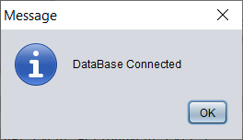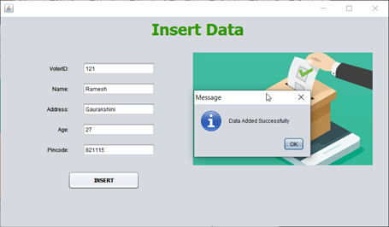

**Show, Update, Remove Records:**

import javax.swing.JOptionPane;

import java.sql.*;

import java.util.logging.Level;

import java.util.logging.Logger;

import javax.swing.table.DefaultTableModel;

public class edit extends javax.swing.JFrame {

Connection con;

PreparedStatement pst1,pst2,pst3,pst4;

DefaultTableModel dtm;

ResultSet rs;

public edit() {

try {

initComponents();

setVisible(true);

Class.forName("org.apache.derby.jdbc.ClientDriver");

con=DriverManager.getConnection("jdbc:derby://localhost:1527/Project","admins","admins");

JOptionPane.showMessageDialog(null,"DataBase Connected");

}

catch (ClassNotFoundException ex) {

Logger.getLogger(Login_form.class.getName()).log(Level.SEVERE, null, ex);}

catch (SQLException ex) {

Logger.getLogger(Login_form.class.getName()).log(Level.SEVERE, null, ex);}

}

private void searchActionPerformed(java.awt.event.ActionEvent evt) {

// TODO add your handling code here:

try{

pst2=con.prepareStatement("select * from voter_list",ResultSet.TYPE_SCROLL_INSENSITIVE,ResultSet.CONCUR_READ_ONLY);

rs=pst2.executeQuery();

ResultSetMetaData rsmd=rs.getMetaData();

int cols=rsmd.getColumnCount();

String colname[]=new String[cols];

for(int i=1;i<=cols;i++){

colname[i-1]=rsmd.getColumnName(i);}

int rows=0;

while(rs.next()){

rows++;

}

String data[][]=new String[rows][cols];

rs.beforeFirst();

rows=0;

while(rs.next()){

for(int i=1;i<=cols;i++)

{

data[rows][i-1]=rs.getString(i);

}

rows++;

DefaultTableModel dtm = new DefaultTableModel(data,colname);

tb1.setModel(dtm);

}

}

catch (Exception e){

JOptionPane.showMessageDialog(null,e.getMessage());}

}

private void editActionPerformed(java.awt.event.ActionEvent evt) {

// TODO add your handling code here:

int i=tb1.getSelectedRow();

try{

dtm=(DefaultTableModel)tb1.getModel();

pst1=con.prepareStatement("update voter_list set name=?, address=?, age=?, pincode=? where voterid=?");

pst1.setString(1,name_text.getText());

pst1.setString(2,address.getText());

pst1.setString(3,age.getText());

pst1.setString(4,pincode.getText());

pst1.setString(5,voter_id.getText());

int r1=pst1.executeUpdate();

if(r1>=1){

JOptionPane.showMessageDialog(this,"Updated Successfully");}

}

catch (Exception e){

JOptionPane.showMessageDialog(null,e.getMessage());

e.printStackTrace();}

}

private void removeActionPerformed(java.awt.event.ActionEvent evt) {

// TODO add your handling code here:

int i=tb1.getSelectedRow();

try{

int r;

dtm=(DefaultTableModel)tb1.getModel();

r = Integer.parseInt(dtm.getValueAt(i,0).toString());

pst3=con.prepareStatement("delete from voter_list where voterid='"+r+"'");

voter_id.setText(dtm.getValueAt(i,0).toString());

name_text.setText(dtm.getValueAt(i,1).toString());

address.setText(dtm.getValueAt(i,2).toString());

age.setText(dtm.getValueAt(i,3).toString());

pincode.setText(dtm.getValueAt(i,4).toString());

int re=pst3.executeUpdate();

if(re>=1){

JOptionPane.showConfirmDialog(null,"Do You really want to DELETE?","Confirmation",JOptionPane.YES_NO_OPTION, JOptionPane.QUESTION_MESSAGE);

JOptionPane.showMessageDialog(null,"Item Deleted");

dtm.removeRow(i);

voter_id.setText("");

name_text.setText("");

address.setText("");

age.setText("");

pincode.setText("");

}

}

catch(Exception e)

{

JOptionPane.showMessageDialog(null,e.getMessage());

}

}

private void tb1MouseClicked(java.awt.event.MouseEvent evt) {

// TODO add your handling code here:

int i=tb1.getSelectedRow();

try{

dtm=(DefaultTableModel)tb1.getModel();

pst4=con.prepareStatement("select * from voter_list where voterid=?");

pst4.setString(1,voter_id.getText());

voter_id.setText(dtm.getValueAt(i,0).toString());

name_text.setText(dtm.getValueAt(i,1).toString());

address.setText(dtm.getValueAt(i,2).toString());

age.setText(dtm.getValueAt(i,3).toString());

pincode.setText(dtm.getValueAt(i,4).toString());

}

catch (Exception e){

JOptionPane.showMessageDialog(null,e.getMessage());}

}

**Show Details Snapshot:**

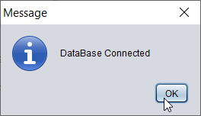

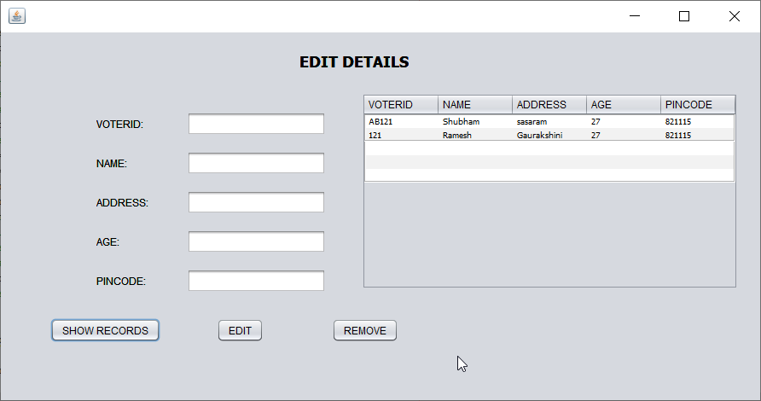

**Edit Details Snapshot:**

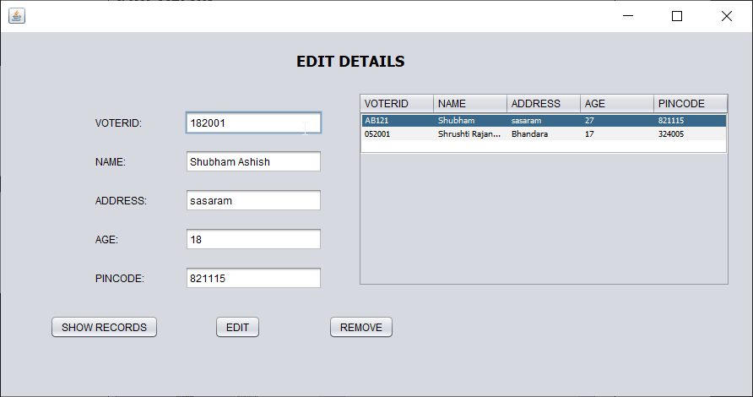

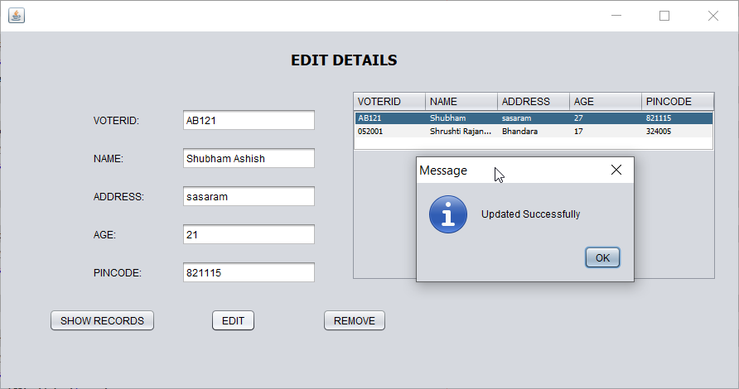

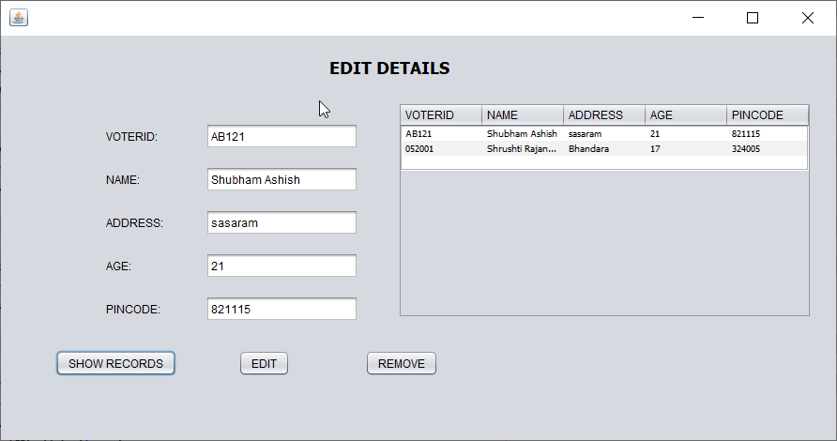

**Delete Details Snapshot:**

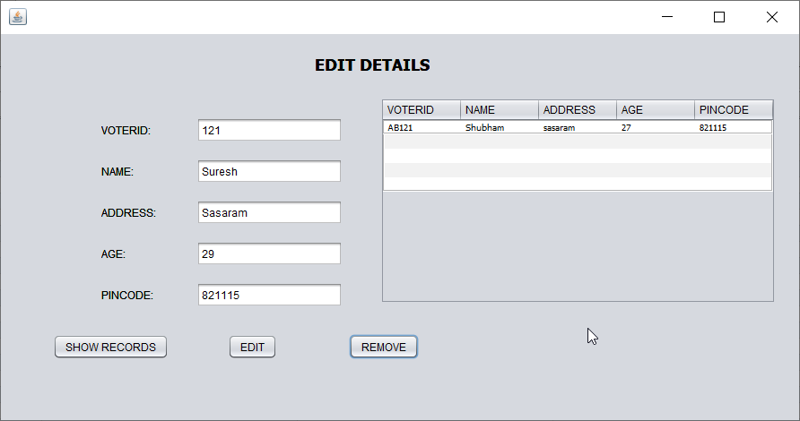

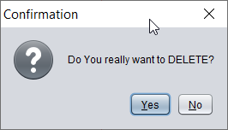

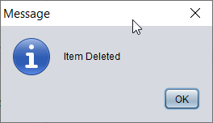

**Search Records:**

import java.sql.*;

import javax.swing.JOptionPane;

import javax.swing.table.DefaultTableModel;

public class search extends javax.swing.JFrame {

Connection con;

PreparedStatement pst;

DefaultTableModel dtm;

ResultSet rs;

public search() {

initComponents();

setVisible(true);

try

{

Class.forName("org.apache.derby.jdbc.ClientDriver");

con=DriverManager.getConnection("jdbc:derby://localhost:1527/Project","admins","admins");

JOptionPane.showMessageDialog(null,"DataBase Connected");

}

catch(Exception e)

{

JOptionPane.showMessageDialog(this,"Error in Connection");

}

}

private void searchActionPerformed(java.awt.event.ActionEvent evt) {

// TODO add your handling code here:

try

{

if(voterid.isSelected())

{

name.setEnabled(false);

age.setEnabled(false);

pst=con.prepareStatement("select * from voter where voterid=?",ResultSet.TYPE_SCROLL_INSENSITIVE,ResultSet.CONCUR_READ_ONLY);

pst.setString(1,voter1.getText());

rs=pst.executeQuery();

dtm = (DefaultTableModel) table.getModel();

dtm.setRowCount(0);

while(rs.next())

{

Object[] row = {rs.getString("voterid"),rs.getString("name"),rs.getString("address"),rs.getString("age"),rs.getString("pincode")};

dtm.addRow(row);

}

}

if(name.isSelected())

{

voterid.setEnabled(false);

age.setEnabled(false);

pst=con.prepareStatement("select * from voter where name=?",ResultSet.TYPE_SCROLL_INSENSITIVE,ResultSet.CONCUR_READ_ONLY);

pst.setString(1,name1.getText());

rs=pst.executeQuery();

dtm=(DefaultTableModel)table.getModel();

dtm.setRowCount(0);

while(rs.next())

{

Object[] row = {rs.getString("voterid"),rs.getString("name"),rs.getString("address"),rs.getString("age"),rs.getString("pincode")};

dtm.addRow(row);

}

}

if(age.isSelected())

{

voterid.setEnabled(false);

name.setEnabled(false);

pst=con.prepareStatement("select * from voter where age=?",ResultSet.TYPE_SCROLL_INSENSITIVE,ResultSet.CONCUR_READ_ONLY);

pst.setString(1,age1.getText());

rs=pst.executeQuery();

dtm=(DefaultTableModel)table.getModel();

dtm.setRowCount(0);

while(rs.next())

{

Object[] row = {rs.getString("voterid"),rs.getString("name"),rs.getString("address"),rs.getString("age"),rs.getString("pincode")};

dtm.addRow(row);

}

}

}

catch (Exception e)

{

JOptionPane.showMessageDialog(null,e.getMessage());

e.printStackTrace();

}

}

private void backActionPerformed(java.awt.event.ActionEvent evt) {

// TODO add your handling code here:

setVisible(false);

new Menu().setVisible(true);

}

**Snapshot**

